Our Trip To Dorchester Market 1

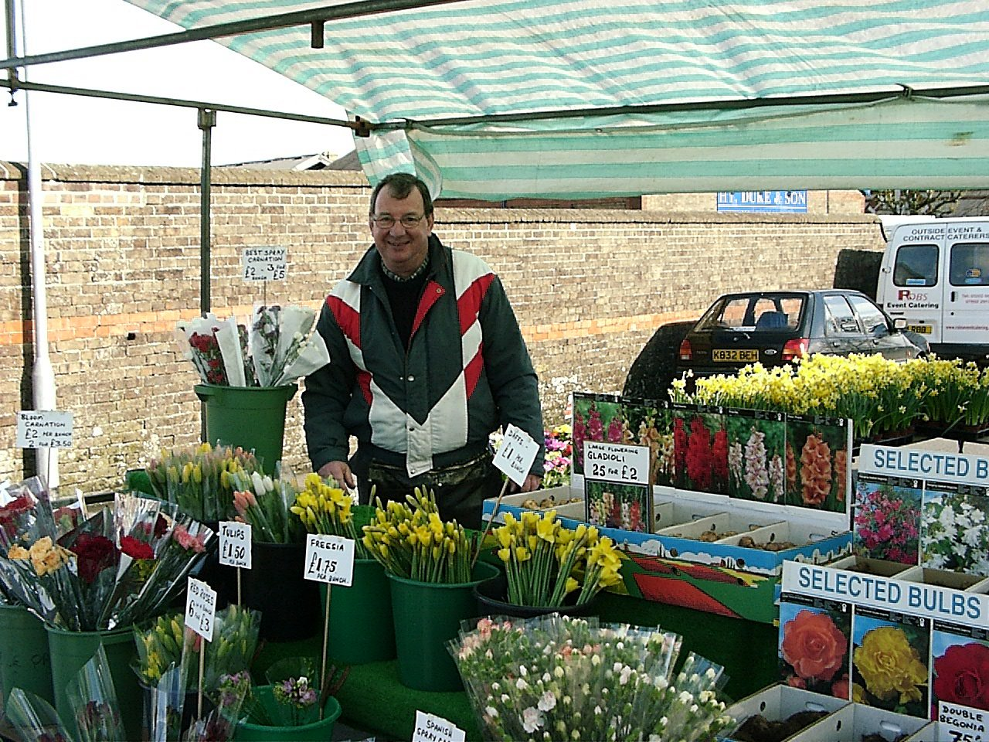 |  | This man is selling flowers. Can you think of the names of different type of flowers?
1.  Hello, my name is  and I sell  . .……………..… .  2.  3. | 4.  5.  6.

Find a name for the man that rhymes with the name of a flower.

