Our Trip To Dorchester Market 2

We visited the fruit & veg stall.

Make 2 lists of what you might like to buy at the stall.

Fruit  1.  2.  3.  4.  5.  6.  7.  8. | 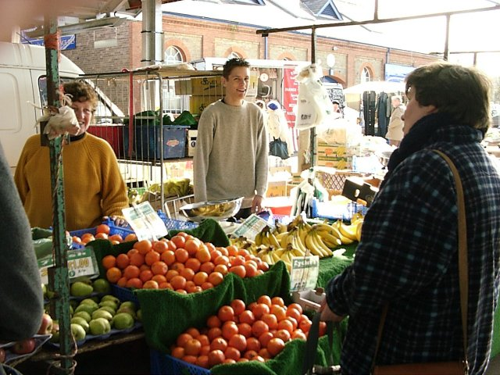 |  | Vegetables  1.  2.  3.  4.  5.  6.  7.  8.
In this box write the names of fruit and vegetables we grow in this country. |  | In this box write the names of fruit and vegetables we do NOT grow in this country and the country they come from.
1.  2.  3.  4.  5.  6.  7.  8. |  | 1. come from  2. come from  3. come from  4. come from  5. come from  6. come from  7. come from  8. come from

