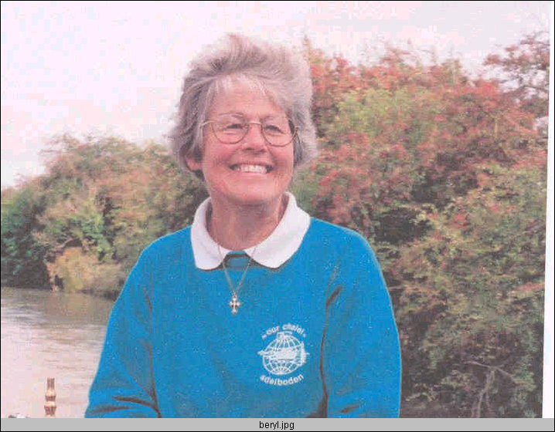 Mrs. Beryl King’s Wartime Memoirs.

In April 2002, Mrs. King was interviewed by the children of
Year 3
at
St. Mary’s Catholic First School.
Click to find out more

