A Day in the Life of the Letterbox
at
Winterbourne Valley CE VA
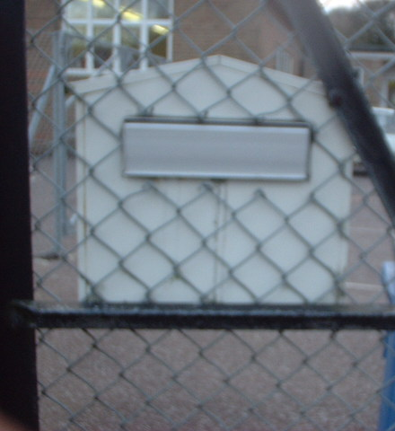
First School

By Year Two
ICT 2.DOC

